
Daniyal Aftab Mirza

WIFI PASSWORD CRACKING

Project Report

This report is to acknowledge that the project report titled "Wifi Password Cracking" has met the required standards for submission as a semester project for the completion of the 1st semester of the Bachelor of Science in Cyber Security at Air University in Islamabad.

Abstract
Wi-Fi cracking involves attempting to gain unauthorized access to a wireless network by exploiting vulnerabilities in its security protocols. Typically, this activity is carried out by hackers or security professionals to assess the network's security or for malicious purposes. However, it's important to note that unauthorized network access is illegal and unethical. Ethical hacking, also known as penetration testing, is a legitimate and legal way to evaluate a network's security, with the consent of the network owner. If you have a genuine need to assess the security of your own network or if you are a security professional conducting authorized testing, it is essential to follow ethical guidelines and legal frameworks. Engaging in unauthorized network access can lead to serious legal consequences.

Semester Project Report

Introduction
Aircrack-ng is a powerful suite of wireless network security tools designed for ethical hacking and penetration testing. Renowned for its effectiveness in assessing Wi-Fi vulnerabilities, Aircrack-ng enables security professionals and enthusiasts to analyze and strengthen the security of wireless networks. From monitoring and capturing network traffic to cracking Wi-Fi passwords, Aircrack-ng offers a comprehensive set of features, making it an indispensable tool in the arsenal of cybersecurity practitioners.

Tools Used
- Kali Linux: is a Linux distribution that includes a wide range of tools for penetration testing and ethical hacking, including tools specifically designed for Wi-Fi cracking.
- TP-Link TL-WN722N: enhances Wi-Fi security assessments, enabling monitor mode, packet injection, and targeted attacks for ethical hacking and vulnerability identification.

PROCEDURE
These steps were followed to gain access to a wireless network.
Module 1: Enabling Monitor Mode
Step 1: We initially examined the status of our network adapter through the ‘iwconfig’ command.
Step 2: We then checked if there are any conflicting background processes using ‘sudo airmon-ng check’ command.
Step 3: In preparation for network access, any conflicting background processes were terminated using the ‘sudo airmon-ng check kill’ command.
Step 4: The wireless network interface transitioned from managed to monitor mode, allowing the capture of all wireless traffic on a specific channel without associating with any particular access point. This transition was achieved using the ‘sudo airmon-ng start wlan0’ command.
Step 5: Confirmation of the successful change from managed to monitor mode was obtained by revisiting the adapter's status with the ‘iwconfig’ command.
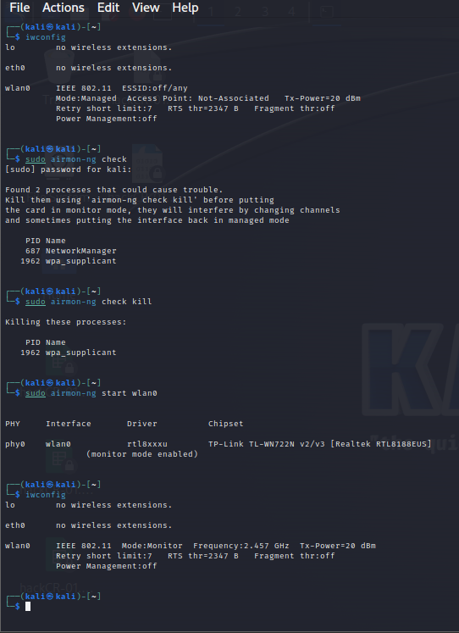
iwconfig
Sudo airmon-ng start wlan0
Sudo airmon-ng check kill
Sudo airmon-ng check
iwconfig

Module 2: Capturing Handshake

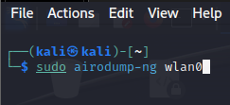
Step 6: Identifying available wireless networks, including their SSID and MAC addresses, was accomplished using the ‘sudo airodump-ng wlan0’ command. The MAC address of the target network's connected device was noted.
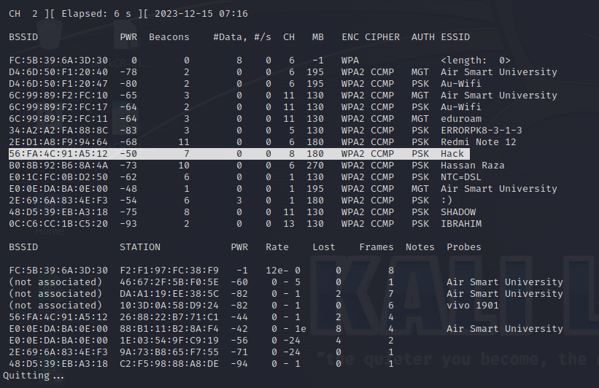

Step 7: A file named "hackCR" was created to store comprehensive network information, utilizing the ‘sudo airodump-ng -w hackCR -c 8 --bssid 56:FA:4C:91:A5:12 wlan0’ command to specify the channel and BSSID for the target network.
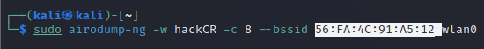
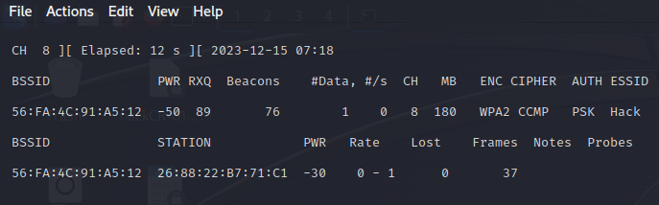

Step 8: The capture of the four-way handshake between the network and the device, often employed in Wi-Fi password cracking attempts, was executed with the ‘sudo aireplay-ng --deauth 0 -a 56:FA:4C:91:A5:12 wlan0’ command.
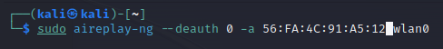
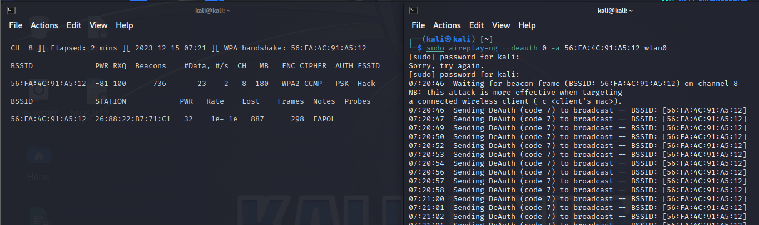

Step 9: The existence of the capture file was verified using the ‘ls’ command.
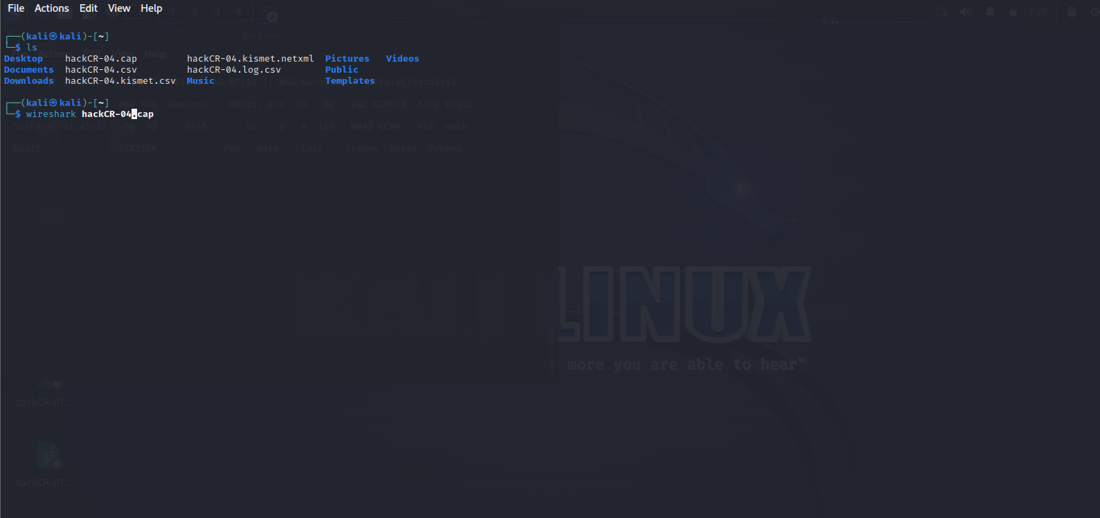

Module 3: Cracking Password

Step 10: The Wireshark application was employed to open the capture file with the command ‘wireshark hackCR-04.cap’.

Step 11: Utilize Wireshark by entering 'eapol' in the filter box to inspect authentication key data packets. The encrypted authentication key is present in 'Message 2 of 4.
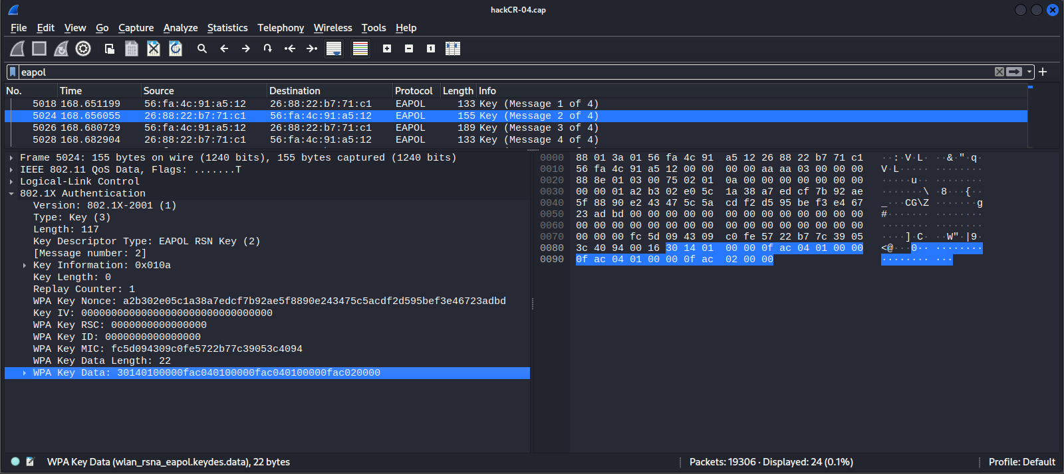

Step 11: To minimize disruption to the network's normal operation, the monitor mode was disabled using the ‘sudo airmon-ng stop wlan0’ command after capturing essential information.
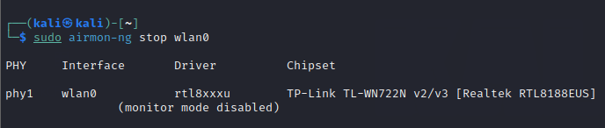

Step 12: Multiple commands were used to deactivate the monitor mode of the network adapter.

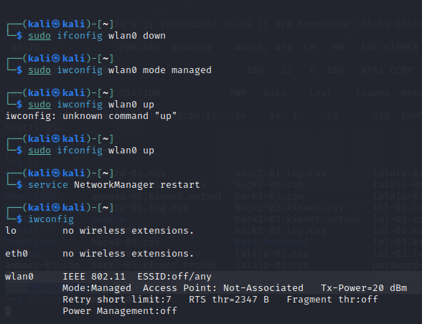

Step 13: Utilizing the captured file, we successfully cracked the Wi-Fi password using the "rockyou.txt" wordlist in Wireshark. The command ‘sudo aircrack-ng /home/kali/hackCR-04.cap -w /usr/share/wordlist/rockyou.txt’ was executed, revealing the password for the targeted network as "12345678".
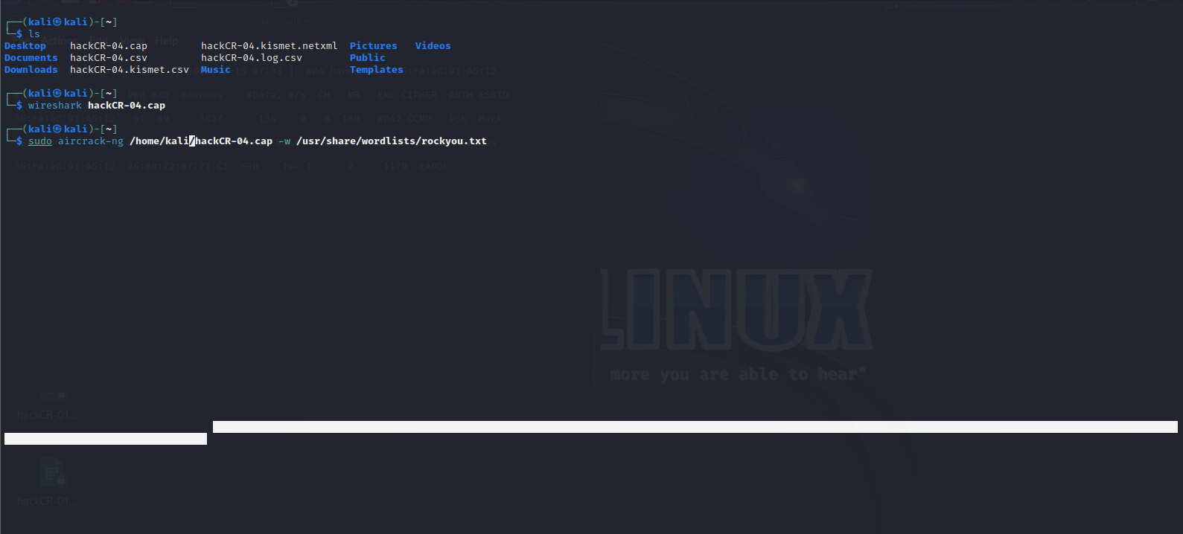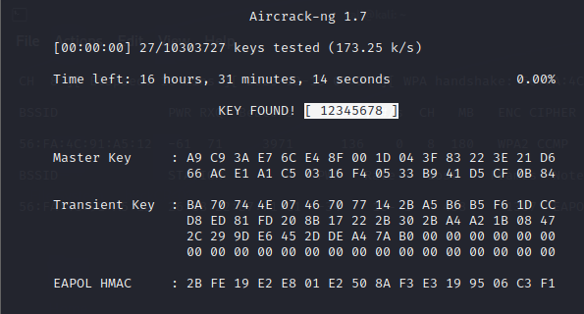
Mitigation
Ensure your network's safety. Set strong passwords, activate WPA3 encryption, and regularly update your router. Periodically check your network's security to maintain a robust defense against potential threats.

Conclusion
In conclusion, the 'Aircrack-ng' project showcased the effective utilization of ethical hacking tools, particularly in Wi-Fi vulnerability assessment. The project's meticulous execution, from enabling monitor mode to password cracking, underscores the significance of robust security practices. To fortify network defenses, employing strong passwords and adhering to ethical guidelines are crucial. 'Aircrack-ng' stands as a valuable asset in the arsenal of cybersecurity practitioners, emphasizing the importance of ethical hacking for a safer digital landscape.
References
- YouTube
- OpenAI
- Web

